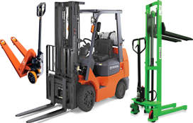



Office Address: B-14 L-27 St. Therese St. Capitol Parkland, Camarin, Caloocan City
Tel No.: 938-2822/546-8527/938-2822/899-2898/899-2868/285-9355
Cellphone No: 09199877756/09255047387/0925-5565262/ 0925-5565262
Email-address: marlene.gmy@mail.com/gmy_hydraulicrepairservices@yahoo.com Telefax: 962-5393
_____________________________________________________________________________________________
QUOTATION
Quote #: GMY-003812 | Date: February 17, 2017
Customer: PRICON MICROELECTRONICS INC. | Reference:
Attention: MS REBECA | Warranty: 60 days
Address: LISP 1 CABUYAO LAGUNA | Terms of Payment: 15 Days
Equipment Model: MITSUBISHI FORKLIFT FG15 | User Location:
Serial NO: F25A-51115

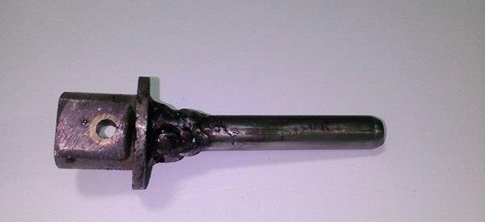

ADDITIONAL PARTS FOR TABLE LIFTER REPAIR
DESCRIPTION | QTY | UOM | UNIT/PRICE | AMOUNT
PISTOM PUMP ASSEMBLY (FABRICATION ) | 1 | PC. |  | Php1,200.00
NET |  |  |  | PHP1,200.00

Quote By: Conforme:

MYLA LAURE ________________________
Account Executive Signature over printed name

